Building Safety Bill and Improvement update

Purpose of report
For discussion.

Summary
This report updates Fire and Rescue Authority Members on the Building Safety Bill and the work for Fire and Rescue Services (FRSs) that flows from its introduction.
Recommendation
That Members note the updates in this paper and comment on the implications for FRS implementation.
Action
Chief Fire Officers to incorporate members’ views into the ongoing preparation by FRSs for the building safety regulator work.

Contact
Gavin Tomlinson - Chief Fire Officer (CFO), Derbyshire Fire and Rescue Service
gtomlins@derbys-fire.gov.uk

Building Safety Bill and Improvement update
Background
- The Building Safety Bill was published in draft form on 20 July 2020 and was subjected to pre-legislative scrutiny by the Housing, Communities and Local Government Select Committee.
- A new version of the Bill was formally introduced on 5 July 2021. Published alongside this was a transition plan (see also the annex) and a response to the select committee report. The Bill had its second reading on 21 July 2021, and entered Committee Stage on 9 September 2021.
- The Bill establishes a Building Safety Regulator (BSR) within the Health and Safety Executive (HSE) to:
  - implement the new, more stringent, regulatory regime for higher-risk buildings (defined as residential buildings over 18m and – following LGA and National Fire Chiefs Council (NFCC) representation – care homes and hospitals over 18m at the design and construction stage).
  - oversee the safety and performance of all buildings.
  - assist and encourage competence among the built environment industry, and registered building inspectors.
- The BSR will rely on FRSs, council building control services and environmental health teams to deliver the regime for higher-risk buildings, which is expected to involve Multi-Disciplinary Teams (MDT).
- The details of how the regime may operate in practice are being worked on through the Joint Regulators Group (JRG) chaired by the HSE, and involving the Department of Levelling Up, Housing and Communities (DLUHC) and the Home Office. Members include Local Authority Building Control (LABC), the LGA, and the NFCC.
- While the JRG has been involved in policy design trials, members are becoming increasingly concerned about the lack of sufficient programme management and join up between the advice of JRG members and senior decision makers. The LGA and NFCC have raised the need for the Government and HSE to increase their engagement with councils and fire and rescue authorities, hence the reason for this report.
Key features of the Bill
- The Bill places the HSE and local regulators under a duty to cooperate and gives the HSE the power to direct councils and fire services. The latter power is to be used only in exceptional circumstances and the Bill provides safeguards to prevent it becoming a default option.
- New buildings will have to pass through three regulatory Gateways in relation to safety – at the planning stage, at the final design stage (before construction can begin) and immediately before occupation when construction is complete.
- In occupation, buildings will need to be registered with the BSR and will require a Safety Case. The Accountable Person (AP, essentially the owner or managing agent) will need to maintain a Golden Thread (detailed information) of information about the building.
- The AP will have a duty to listen to residents who raise building safety concerns – and if residents feel ignored, they can raise issues with the BSR.
- Leaseholders will have to pay a Building Safety Charge (BSC) that covers the costs of operating the new regime. The Government has said that the new BSC will not be able to be used to pass on costs to leaseholders for remediation works. However, these will still be chargeable under existing leasehold arrangements, which vary according to leases, but generally allow APs to pass costs on to leaseholders.
- The first stage of the new regime Planning Gateway One began in August 2021, which requires those planning to build buildings in scope of the new regime to produce a fire statement to ensure applicants have considered fire safety issues as they relate to land use planning matters (e.g. layout and access).
Concerns with the Bill
- The NFCC is generally supportive of the Bill, and recognises the urgent need for it to be passed in order to prevent further unsafe buildings from continuing to be constructed. However NFCC has submitted written evidence expressing concern that the scope of the Bill could be wider, the speed at which its scope can be expanded, and the constraints on its expansion. They have argued that height is not an effective determinant of risk and that care homes under 18m should be included in the new regime.
- The NFCC has also expressed concern about:
  - The removal of competition in building control does not go far enough; the ability for a client to choose their own regulator should be removed for the whole of the built environment.
  - The watering down of provisions in relation to the refurbishment of buildings, and possible watering down of the gateways provisions.
  - The conflict between the new building safety system and the Government’s planning white paper.
  - The adequacy of the product safety provisions.
- The Bill impacts councils and FRAs as regulators and councils as housing providers. The main issues for local regulators arising from the Bill are:
  - The shortage of expertise both inside the fire and rescue service and in private industry, including but not confined to the shortage of fire engineers;
  - The funding for training and capacity increase ahead of implementation;
  - The operation of the recharging scheme that allows councils and FRSs to reclaim cost of new burdens BSR work from the HSE;
  - The interaction of the new Bill and other relevant legislation – the Housing Act, the Fire Safety Order/Fire Safety Act.
  - The balance of democratic accountability for local services and the duty to cooperate with the HSE.
- The impact of the Bill also interfaces with the impact of the Fire Safety Act (FSA) and associated changes to the Fire Safety Order (FSO), for example:
  - The FSA will require building owners to review fire risk assessments on many residential buildings (a prioritisation tool will allow owners to divide stock between properties that require immediate action, action in the medium term and those that need not alter their cycle of updating risk-assessments).
  - Regulations will be introduced later this year relating to premises information boxes; fire door checks and lift checks.
  - Further announcements are expected from the Home Office on personal emergency evacuation plans (PEEPs).
Funding and the operating model
- The key concern is the balance between the demands to be placed on local regulators and the funding available:
  - The HSE does not appear to be clear about the extent to which it will rely on local building control and FRS to deliver its inspection and enforcement functions, and the operating model has not been shared with local regulators.
  - Both NFCC and LABC have been warned to expect much lower spending review settlements than would be required to deliver the functions expected of them.
    - This could see local regulators diverted away from existing work in order to meet their duties under the Building Safety Bill. However, there will be a number of buildings not included in the new regime that represent an even higher degree of risk locally. If the HSE employees its own fire engineers and building control surveyors, or contracts private companies to deliver its functions, this may have a damaging effect on local services. Both FRSs and local building control need to retain the expertise required to deliver the new functions, and importantly to continue to deliver existing functions.
  - Once cost recovery mechanisms are in place, it is assumed that 70 per cent of the cost will be recovered in the first two years, increasing towards 90 per cent by the third year of cost recovery. However, secondary legislation is required in order to establish cost recovery powers. This may take an additional year (or longer) to be put in place following Royal Assent. Therefore, cost recovery may not reach 90 per cent until 2026-27 at the earliest, and is never expected to cover more than 90 per cent.
  - On behalf of English FRSs, NFCC have asked for just over £40m over three years to reach around £20m pa which is estimated to be the cost to FRS of the new regime when fully operational from 2024-5. Its estimates have been agreed by the Home Office, but the bid comes under DLUHC’s budget and it has been told to expect no more than £7.5m per annum for start-up costs over the three year SR period (about half of what it needs).
  - The law is framed in such a way as to oblige regulators to deal with new buildings therefore it will be work on existing buildings which is likely to be cut. The funding on offer implies there is a risk that:
    - The HSE needs to stretch the Safety Case work they are planning to complete in 5 years, to over a decade, or;
    - The HSE may place a greater reliance on local FRSs to implement a higher level of inspections under the FSO than may otherwise be programmed into Risk Based Inspection Programmes (RBIPs).
Protection staffing
- Capacity and capability in FRS protection teams has long been a challenge with most facing challenges to resourcing in order to deliver their current FSO obligations.
- A protection uplift grant from the Home Office has been in place since the last Spending Review to improve this position and provide a better baseline from which to build additional capacity. Going forwards, FRS’ will need to balance out the demands of both regulatory regimes and it is essential therefore that we ensure they are appropriately resourced to do so.
- NFCC’s modelling on the impact of the new regime suggests that on average across England, FRSs need to increase their numbers of competent fire safety staff by more than 30 per cent.
- NFCC continue to make representation for continuation of the Protection Uplift grant, but it is not yet known if this will continue. In preparing bids for increased protection funding, NFCC face significant challenge back from central government about the division and balance of protection funding decisions which are made locally. This is particularly the case when the Home Office compares local protection funding decisions to budgets which are allocated for operational response functions. This is also likely to become an increasing area of priority for HMICFRS.
Risks
- In 2011 the Department for Communities and Local Government (DCLG) published new burdens doctrine – guidance for government departments. Under this doctrine, the Cabinet agreed that to ensure the pressure on council tax is kept down, the net additional cost of all new burdens placed on local authorities (including fire and rescue authorities) by central Government must be assessed and fully and properly funded.
- The doctrine defines a new burden as any policy or initiative which increases the cost of providing local authority services. This includes duties, powers, or any other changes which may place an expectation on an FRA. In the context of the Bill this responsibility falls to DLUHC.
- Section 13 of the Bill contains provisions that would enable the BSR to direct a FRS to “do anything specified in the direction”. The Bill provides powers for an FRS to do anything for the purpose of facilitating the exercise of relevant functions.

- Should the BSR ‘direct’ a FRS to take action that goes beyond the commitments of its IRMP without fully funding the cost of doing so, FRAs may need to choose between a number of statutory duties, without having the funding to support them all.
- They may therefore need to consider their priorities and select which statutory duties will be met, and those which will not. Therefore, in weighing-up the risks, they choose to put aside the direction issued by the SoS under the BSA.
- This may involve diverting protection resources provided by the FRA to meet requirements in an IRMP/RBIP (e.g. audit of high-risk premises that is not in-scope of the BSR) across to undertake activities required by the BSR. This would result in a pre-planned audit of a high-risk premises not being carried out as planned by the FRS, in accordance with its RBIP.
- Alternatively, this may involve diverting operational resources (e.g. closing a fire station) to free-up the finances needed to support the work directed by the BSR, again in conflict with requirements in the IRMP. This could result in failure to provide the level of operational cover prescribed in an IRMP, and possibly a failure to achieve an appropriate attendance time, with subsequent loss of life.
- Before a direction may be given by the SoS, the Bill as drafted requires the BSR to first make a written request of the FRA, and requires the BSR to have regard to any written representation received from the FRA in response. Where an FRA considers that a proposed directive is likely to have an adverse effect on the FRA’s IRMP, such as in situations similar to those examples outlined above, it would be reasonable to expect that the BSR would not proceed to ask the SoS to issue a directive.
Opportunity cost estimates
Estimated Higher Risk Premises (e.g. Hospitals, Care Homes) that go uninspected if resources are diverted to meet the BSB – England
Year | 2023/24 | 2024/25 | 2025/26 | 2026/27 | 2027/28 | 2028/29
Safety Case impact | 3,150 | 3,150 | 3,150 | 3,150 | 3,150 | 3,150
Gateway 2 Impact | 948 | 980 | 1013 | 1046 | 1069 | 1103
Total | 4,098 | 4,130 | 4,163 | 4,196 | 4,219 | 4,253

- The table above provides NFCC’s estimates for England of the risks and opportunity costs if existing resources were diverted away from RBIP activity in order to undertake BSR work. This shows the numbers of buildings that will go uninspected as a result. Analysis undertaken in November 2019 demonstrated that similar levels of resourcing are needed to inspect high rise residential buildings (HRRBs) as are needed for other, higher risk buildings (which includes buildings such as Hospitals and Care Homes).
- While new build hospitals and care homes over a certain height will be included within the construction elements of the new regime, ones that are already built and in use or occupation, will not form part of the new regime. This means FRSs will be expected to continue inspecting these as part of existing RBIPs.
- The levels of competency required to undertake work in higher risk premises, are similar to those needed for the new regime. Pressures for skilled personnel are exacerbated by demand in the private sector, particularly for individuals with the competence to assess external wall systems, and those who will have the required skills in the future needed by Building Control Bodies, the HSE, and companies in the private sector specialising in design, architecture, construction and fire safety. It can take between three to five years to train fire safety personnel, depending on what types of role they are undertaking.
- If the BSR directs specialist staff towards HRRBs, the remaining pool of officers available for other work are likely to be competent only to the level required for lower risk premises. This will create a gap of people to inspect buildings which present an even higher risk than HRRBs.
- If new burdens funding is not found for FRSs to deliver the BSB then up to 4,098 higher risk premises may go uninspected in year one, increasing to 4,253 by year six.
- Such a departure from RBIP activity will present legal risks to FRA’s, if they deviate from delivery plans which have already been consulted on.

Timescale
- The Building Safety Bill is expected to receive Royal Assent in Spring – summer 2022 with commencement of the new regime under the Building Safety Regulator 12-18 months following (earliest April 2023).
- The report of phase two of the Grenfell Tower Inquiry is expected in 2022, which is also expected to contain recommendations for FRS.
Implementing the Bill
- The Bill will require MDTs working to the Building Safety Regulator (BSR, sitting within HSE) to approve new multi-occupied residential buildings over 18m at planning stage, design stage (before construction can begin) and construction stage (before occupation can take place). Numbers of estimated new builds, based on known data, are likely to range from 400 – 800p.a. It is also assumed there will be around 600 major refurbishments on average (over ten years).
- The Bill will also require the Building Safety Regulator to approve safety cases for all existing multi-occupied residential buildings over 18m (12,500 or so). It is estimated that as existing regulators of fire safety in occupied buildings, that the majority of the new burden for Safety Cases will fall to FRSs.
- The HSE intends to deliver the approval of Safety Cases in five tranches, one tranche per year starting in 2024-5.
- The safety case approach focuses on Accountable Persons and whether the regulator has confidence in them, rather than on the buildings they manage. Instead of a checklist approach the HSE wants a culture change.
Next steps
- NFCC continues to work via the JRG and other forums to support the HSE in the effective development of a target operating model towards which FRSs can begin making more detailed plans.
- In the meantime, Derbyshire FRS will work with the NFCC to help identify additional resource requirements to inform recruitment, development and training of additional fire safety inspecting officers and fire safety engineers.
- FRA training: The LGA offer a building safety session on the Fire Leadership Essentials course. There was a session on building safety at the fire conference this year. In planning next year’s conference, the Fire Services Management Committee will consider the opportunity to raise FRA awareness of the Fire Safety Act and Building Safety Bill.
- Derbyshire FRS will continue to support the Authority’s work to keep residents safe and reform the buildings safety system.

Annex 1 – Estimated Legislative Timetable
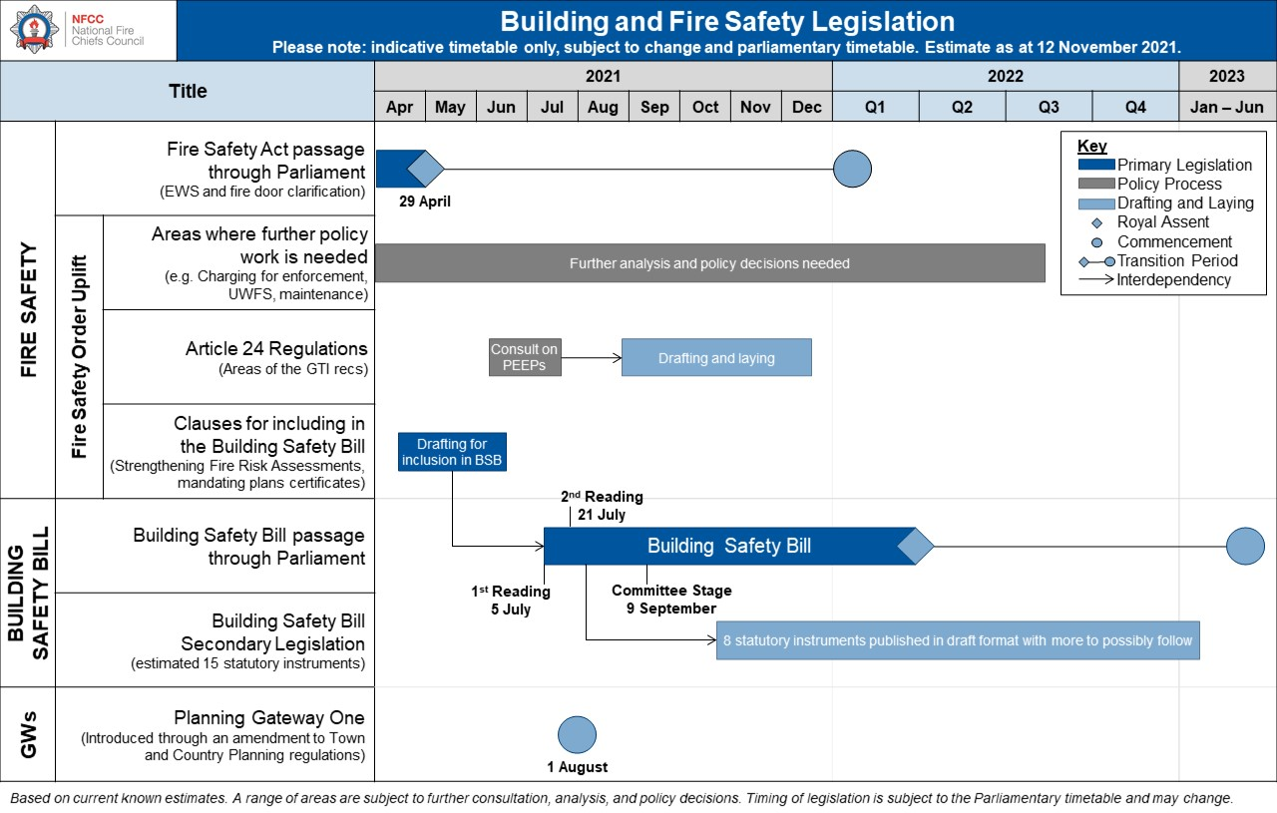

Annex 2 – Glossary of terms
Building Safety Bill (BSB) | Bill currently going through Parliament, which builds on the outcomes of the Independent Review of Building Regulations and Fire Safety that the Government commissioned following the Grenfell Tower Fire.  Building Safety Bill: important documents GOV.UK  Factsheets related to the Building Safety Bill on GOV.UK
Building Safety Charge (BSC) | The Building Safety Bill establishes new legal duties for landlords and building owners. There will be a cost associated with some of these duties, which can be passed to leaseholders through a new Building Safety Charge.  Building Safety Charge Factsheet for landlords and building owners GOV.UK  Building Safety Charge Factsheet for leaseholders GOV.UK
Building Safety Regulator (BSR) | A new regulator, proposed by the BSB, which will be run by the Health and Safety Executive (HSE)  Building Safety Regulator Factsheet GOV.UK
The Fire Safety Act (FSA) | Passed in 2021, yet to commence, the Fire Safety Act clarifies that the FSO applies to:  - the building’s structure and external walls (including windows, balconies, cladding, insulation and fixings) and any common parts  - all doors between domestic premises and common parts such as flat entrance doors (or any other relevant door)  Fire Safety Act information GOV.UK
Fire Safety Order (FSO) | The Regulatory Reform (Fire Safety) Order 2005
Gateways | The name for the proposed new regime for more stringent control of new buildings during design and build phase.  Building control regime for higher risk-buildings (Gateways 2 and 3) Factsheet GOV.UK
Golden Thread | Proposed requirement as part of the new regulatory regime to create and maintain a golden thread of information. The golden thread is both:  - the information about a building that allows someone to understand a building and keep it safe, and  - the information management to ensure the information is accurate, easily understandable, can be accessed by those who need it and is up to date  Golden Thread Factsheet GOV.UK
High Rise Residential Buildings (HRRBs) | For the purposes of the BSB, residential buildings that are at least 18 metres in height or have at least 7 storeys and have at least two residential units.
Higher Risk Buildings (HRBs) / Buildings in Scope | Initially the new regime will only apply to residential buildings that are at least 18 metres in height or have at least 7 storeys and have at least two residential units. It also applies to care homes and hospitals meeting the same height threshold during design and construction.  Buildings included in the new more stringent regulatory regime Factsheet GOV.UK
Integrated Risk Management Plans (IRMP) | Under section 4.6 of the Fire and Rescue National Framework for England, each FRA must produce an Integrated Risk Management Plan (IRMP) – now commonly referred to as a Community Risk Management Plan (CRMP).  - These plans will include a management strategy and a risk-based inspection programme (RBIP) for enforcing the Fire Safety Order  These plans must also:  - Provide an up-to-date risk analysis of all foreseeable risks  - Demonstrate how prevention, protection and response activities will be used to prevent fires and other incidents, and mitigate the effects of incidents that occur in a way that makes best use of available resources  - Outline required service delivery outcomes including the allocation of resources for the mitigation of risks  - Cover at least a 3-year time span  - Consult with the community, its workforce, Rep bodies and other stakeholders on the proposed content of the plan  - Be easily accessible and publicly available
Local Authority Building Control (LABC) | Organisation representing all local authority building control teams in England and Wales.
Risk Based Inspection Programme (RBIP) | A management strategy for enforcing the Fire Safety Order which prioritises resources based on risk. FRAs are required by the Home Office to “target their fire safety, prevention and protection resources on: those individuals or households who are at greatest risk from fire in the home; those most likely to engage in arson or deliberate fire setting; and on those non-domestic premises where the life safety risk is greatest. Consideration could also be given to non-domestic premises which are at risk from fire in order to mitigate loss to economic wellbeing.”
Safety Case | The Building Safety Bill introduces new requirements for building owners to assess and manage building safety risks in buildings within scope.  Safety Case Factsheet GOV.UK

